Homework from 31.03.2023

Рафи Цигаров №2201261077 Информатика

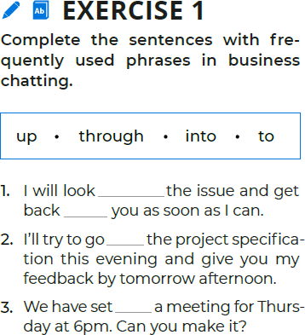

Exercise 1

1. into

2. to

3. up

Exercise 1 B

1. I will tell him what I love to do in my free time and what my hobbys are.

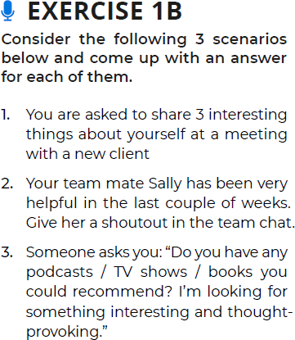

Exercise 1 B

3. For podcasts I will recommend him to watch on youtube the channel “Linus Tech Tips” and “The H3 Podcast”.

Exercise 1 B

2. I will bring all the attention for a moment to tell how much I appreciate all the help Sally has done in the last couple of weeks in front of the team.

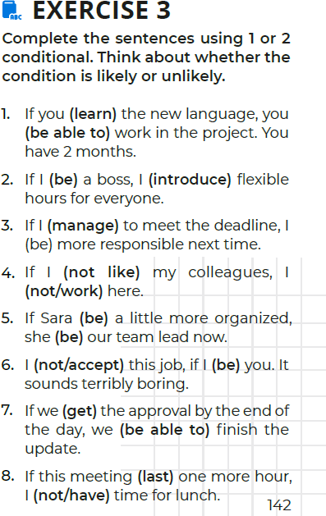

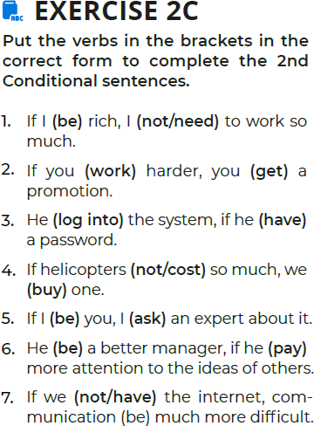

Exercise 3

1. were learning, wouldn't be able to
2. was a boss, I would introduce
3. had to manage, would be more
4. didn`t liked , wouldn`t
5. was , would been
6. wouldn`t accept , if I was
7. get , would be able to
8. lasted , would`t have time for lunch.

Exercise 2 C

1. were , wouldn’t  need
2. worked , woud got
3. woud log into , had
4. didn`t cost , bought
5. was , would ask
6. woud be , was paying
7. didn’t had , would be

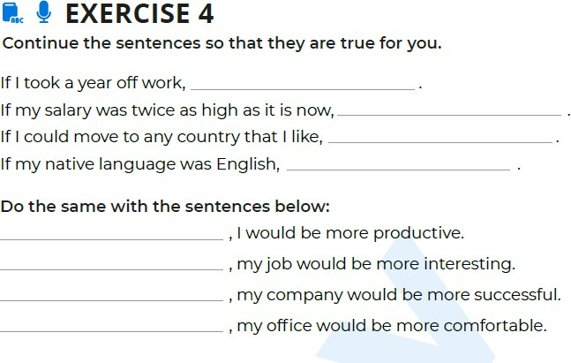

I would be very bored.

I would be going to excursion more often.

I would go to Germany.

I would be more confident in myself.

If was not lazy

If i coud work with better team

If most of my ideas were good

If I was more organized